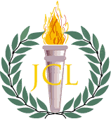

**Any questions?** [**www.ojcl.org**](http://www.ojcl.org) **or call/Text:   
Northeast Gubernator Allison Kao: (216) 855-4288   
Northwest Gubernator Eleni Packis: (440) 596-8539**

**2013 Northwest & Northeast Ohio Make-A-Difference-Day**

**(sponsored by the Ohio Junior Classical League)**

**Where: 800 Sharon Drive,**

Westlake**,** OH **44145**

**When: Saturday, November 16, 7-9 pm**

**What: A fun, Classics-themed party thrown by the OJCL for Youth Challenge participants with physical disabilities. Bring a cheerful attitude and please wear your best toga!**