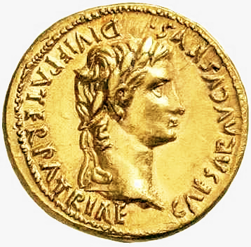
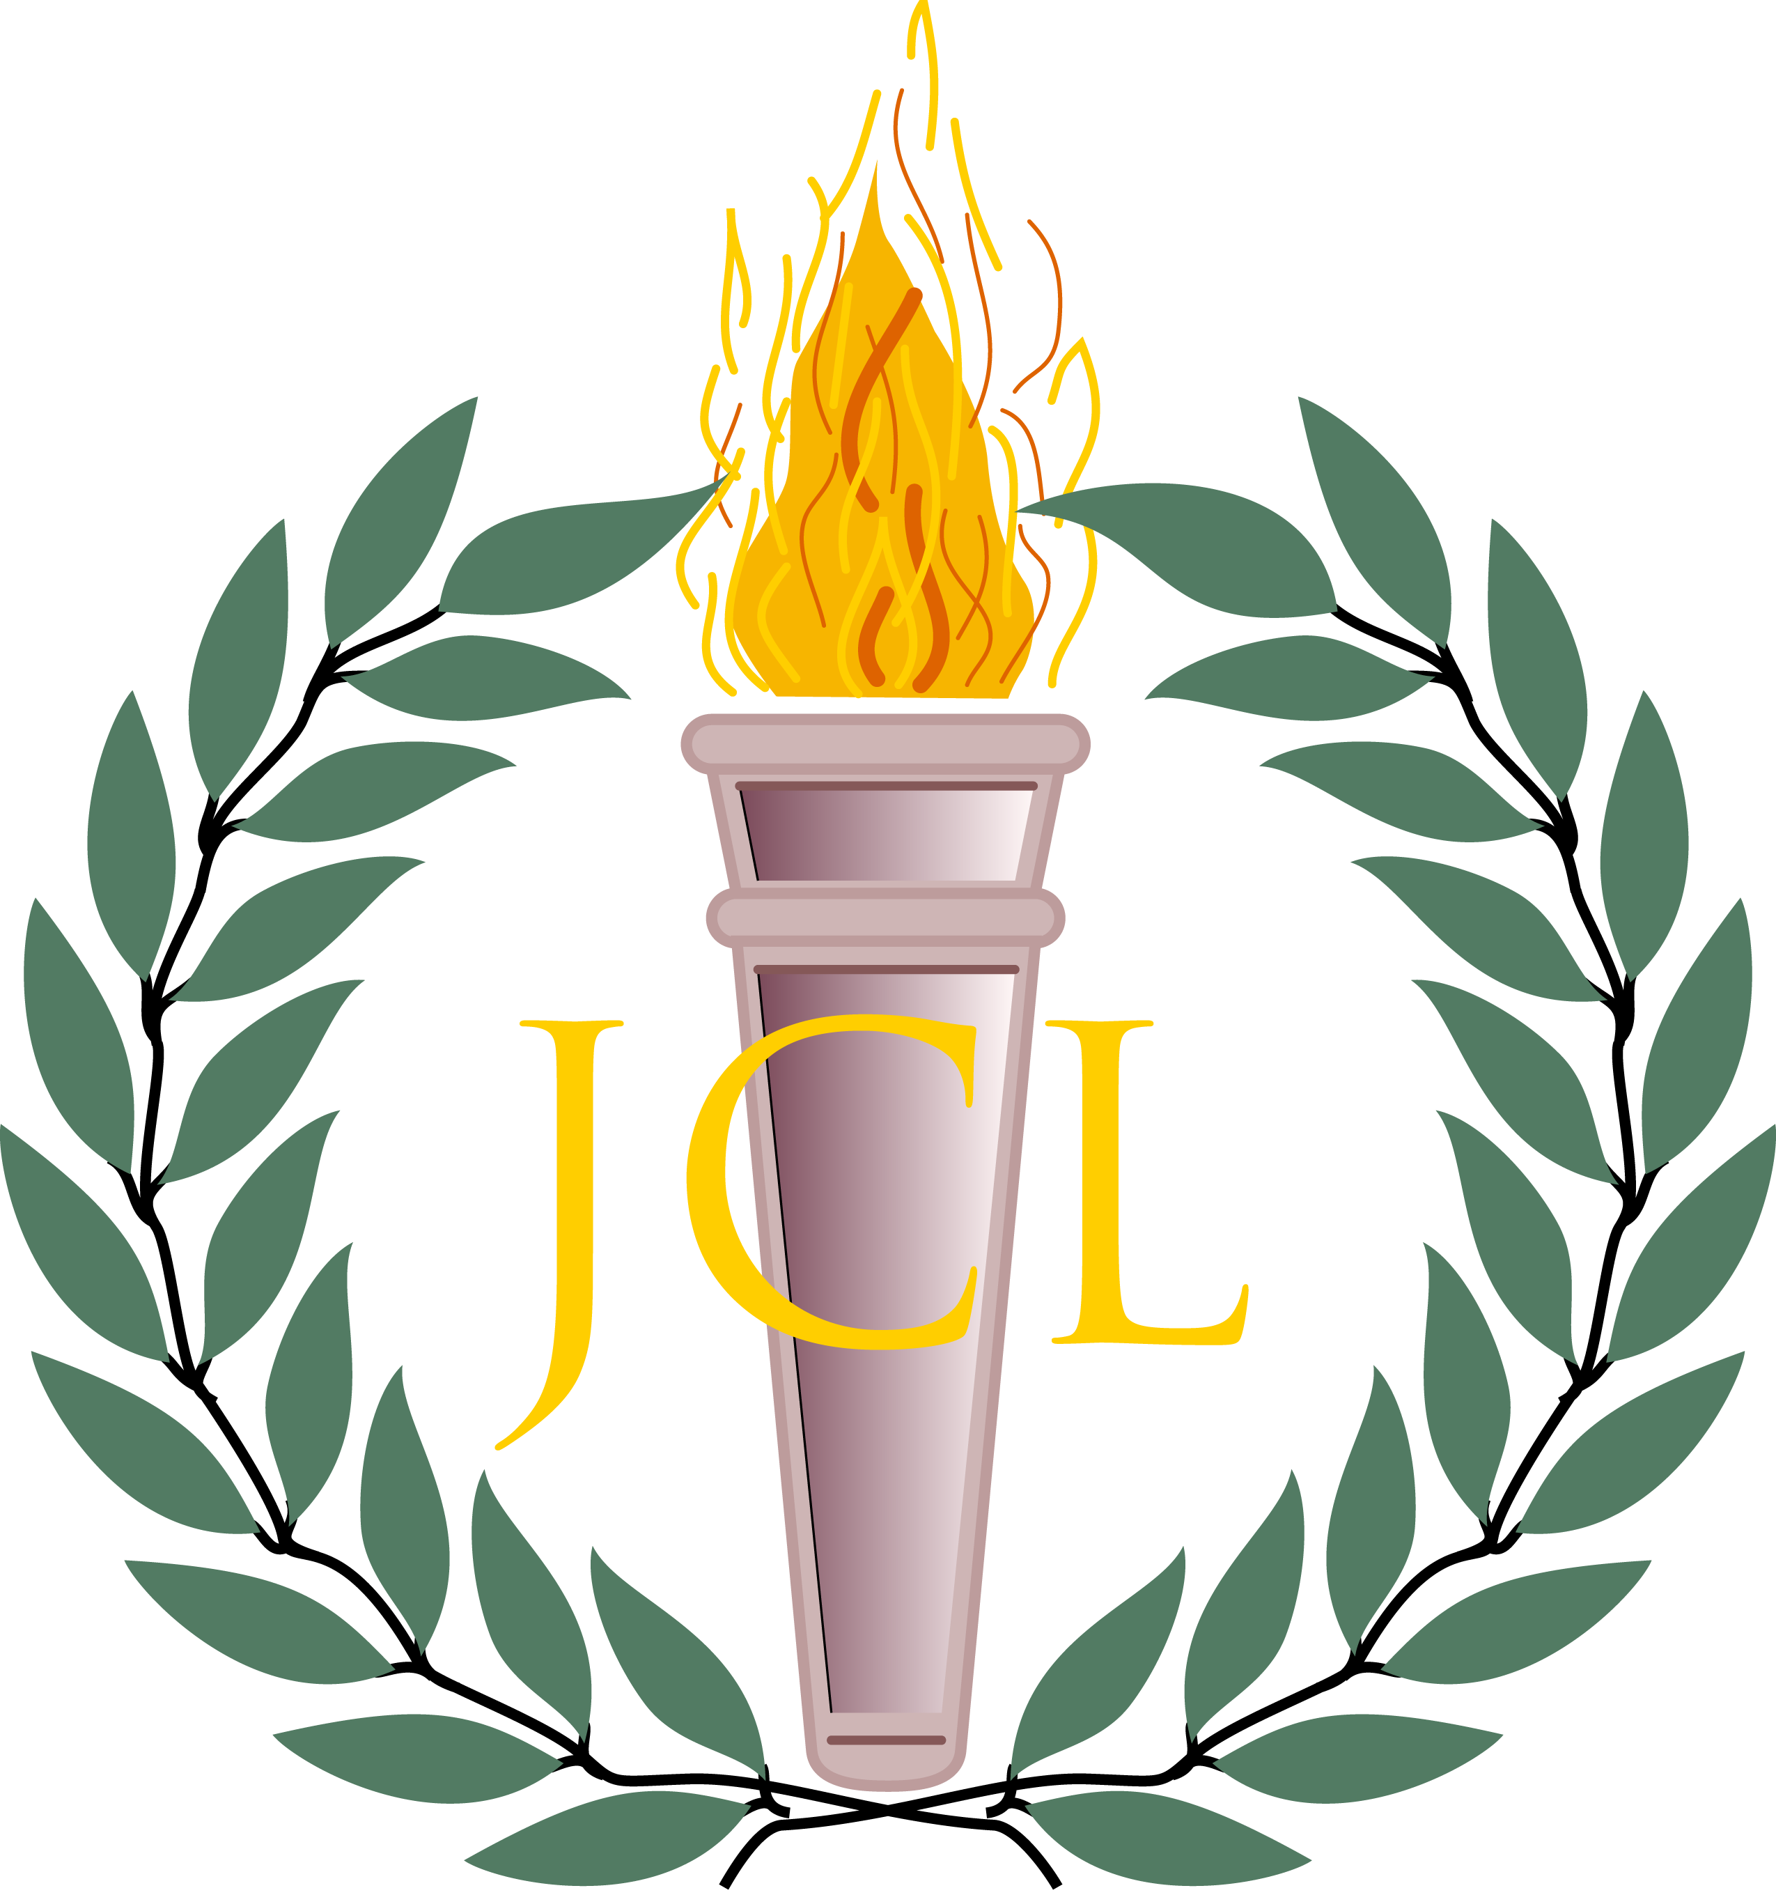

NE/NW OJCL Region Make a Difference
Day
Sunday, October 25th, 2015
1:30 – 4:00 pm
Cleveland City Mission – Laura’s Home
18120 Puritas Ave.
Cleveland, OH 44135

We will be playing games, coloring, and celebrating the classics with the kids, ages 7-12, at the City Mission!
Be sure to wear your toga! Please use the SignUpGenius link to sign up to bring a snack to the party!

Questions? Contact:
NE Gubernator Vishnu Kasturi at neguber@ojcl.org or (216)-789-4304
NW Gubernator Bradley Katcher at nwguber@ojcl.org or (440)-666-7714

