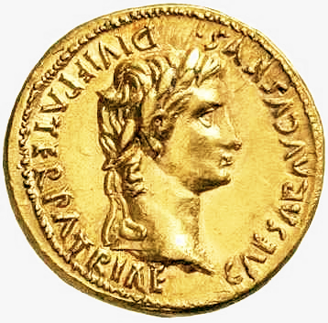
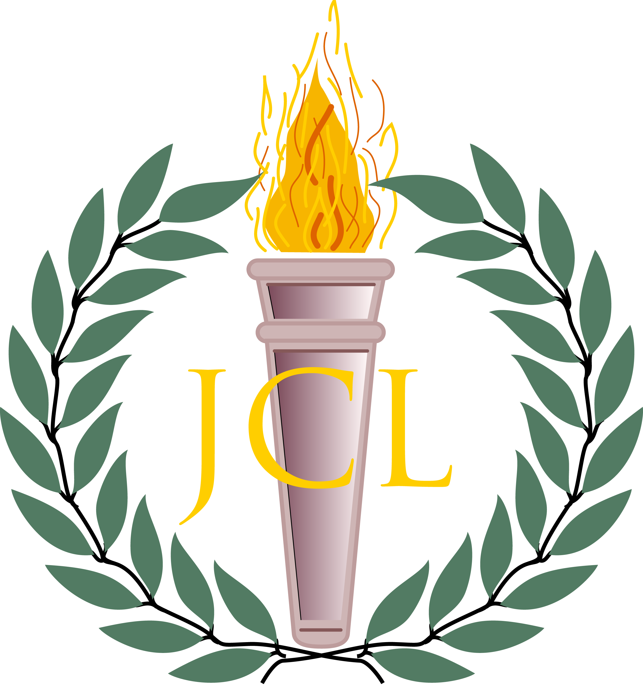

NE/NW OJCL Region Pre-Nationals Picnic
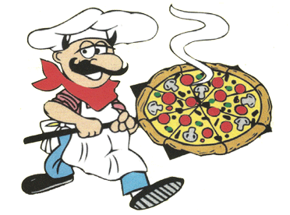
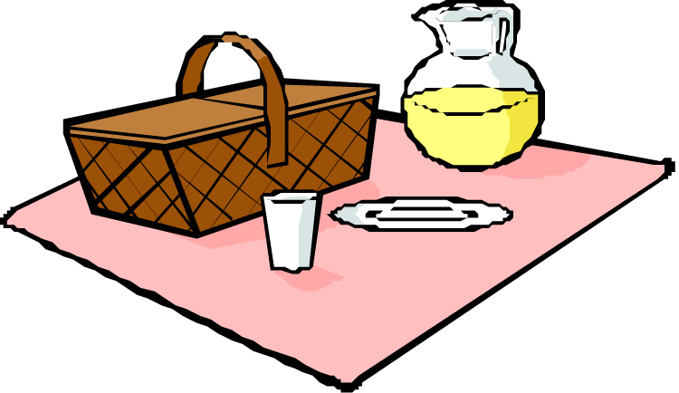
Sunday June 28th, 2015
1:00 – 4:00 pm

Upper Edgewater Park
Cleveland, OH 44102

Pizza will be provided, but please bring drinks, snacks, desserts, and necessary cups/bowls/plates/utensils!

Questions? Contact:
NE Gubernator Vishnu Kasturi at neguber@ojcl.org or (216)-789-4304
NW Gubernator Bradley Katcher at nwguber@ojcl.org or (440)-666-7714

