2017 Medusa Mythology Exam
The Medusa Mythology Exam is a 40 question multiple-choice test given every November to over 10,000 high school students from across the United States. This exam is much more challenging than the National Mythology Exam and requires a thorough knowledge of Greek mythology.
The theme of this year’s competition was ‘Mythological Women: Magnificent and Maleficent.’ Famous women include: the witch Circe, who transformed Scylla into a dog-headed monster and changed Odysseus’ men into pigs; Pasiphae, who gave birth to the bull-headed Minotaur; and the Sirens, whose beautiful singing lured sailors to their death.
28% of Summit students earned an award this year.

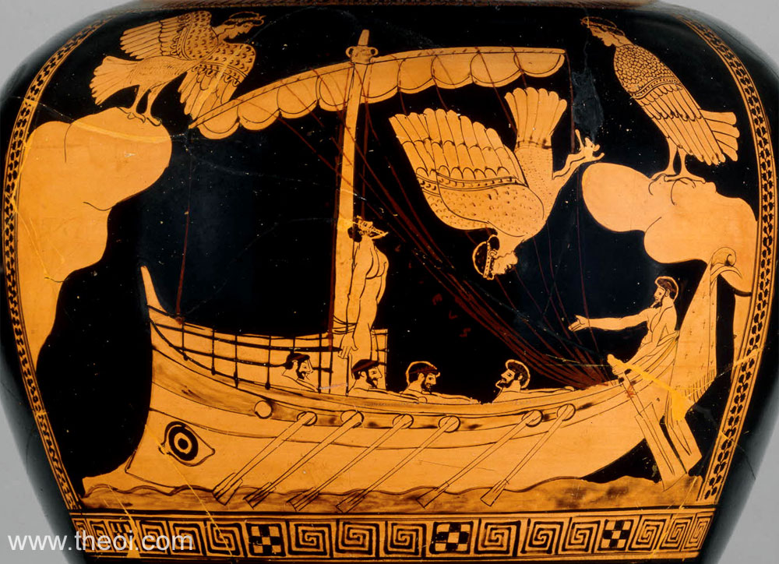

This Greek red-figure vase painting shows Odysseus tied to the mast of his ship so that he was able to hear the song of the Sirens and live to tell about it.

‘Corona Olivae’ Certificate – T.J. Armstrong, Isa Bishop, Maliah Bricking, Michelle Chen, Erin Devine, Brandon Harris, Emily Harris, Elsa Khan, Caroline Kubicki, Owen McEachern, William McLane, Connie Nelson, Sam Parker, Reagan Sutton, Thomas Zhang

‘Corona Laurea’ Certificate – Parker Bricking, Ryan Burns, Julia Dean, Joseph Delamerced, Caroline Klette, Kathryn Sullivan

Bronze Medal – Kendall Richard, Jennifer Sullivan

Silver Medal – Iren Calderon, Jimmy Fraley (top Summit score, 35 out of 40), Nicholas Stanis

