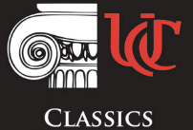
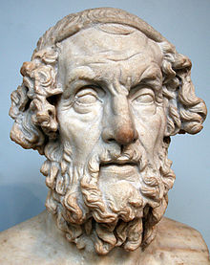
University of Cincinnati Classics Club, and the Department of Classics are proud to present the third annual...

HOMERATHON

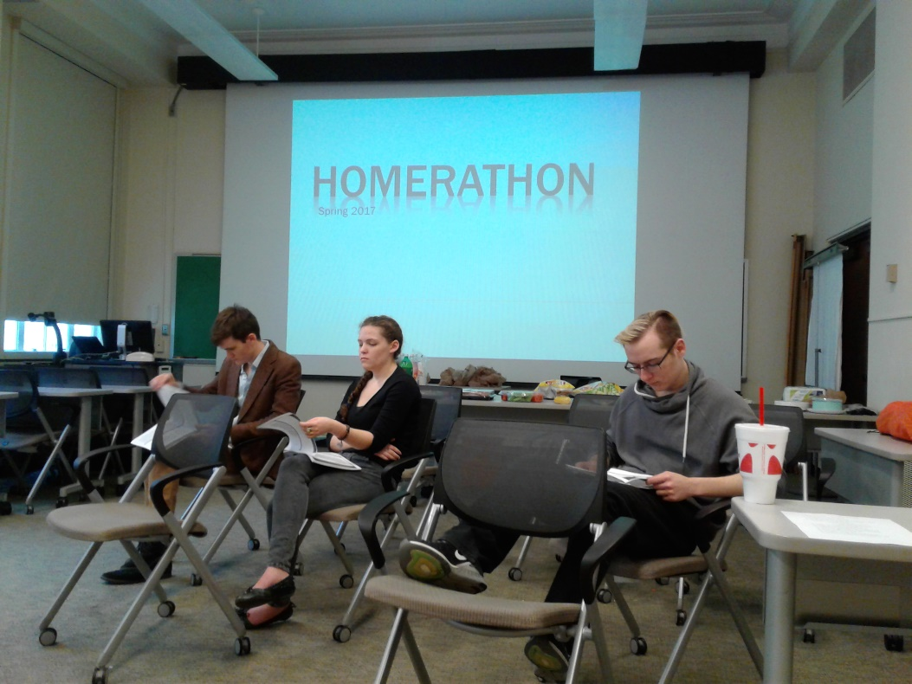
Where: University of Cincinnati, outside Blegen Library (directions below); alternative rain location: inside Blegen
When: April 14, 2018, from 10am to 3pm
What: Live readings of selections from Homer’s Iliad and Odyssey, with tours of Blegen Library’s collections and UC’s ancient materials collections (including pottery, coins, and Bronze Age swords). Meet members of the Classics Club, learn about UC’s Classics and Classical Civilization programs, and celebrate Homer’s works with lunch and a cheese party and fun and games!
Questions: Contact Margaret Kammerer, Classics Club Treasurer, kammerms@mail.uc.edu
Follow us on Facebook (UC Classics Club) to RSVP and to get final schedule and live updates of events!!

Detailed schedule to follow, map and directions below.
April 14, 2018
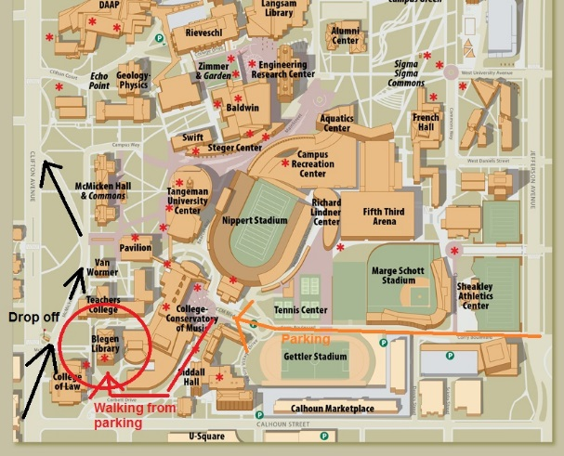

If simply dropping off students by car or bus:
- Enter McMicken Circle on Clifton Ave. - the entrance is at the light next to UC Law, directly across the street from Deaconess Hospital, it is marked by the flag pole.
- Drop students off as soon as you reach the circle, where it is marked “Pick up/Drop off”. Continue down the hill to leave—directions for parking are below.
- Walking directions: Students will walk to their right—Blegen Library will be right off the circle and signs will be marking the area

If you're planning on staying and need to park:
- If you have dropped students off, turn right leaving McMicken Circle, then turn right onto Martin Luther King Jr. Dr., then right again on Jefferson Ave.
- Turn right on Corry Blvd, and continue straight toward CCM
- You will reach the CCM garage and drive underground
- Take an elevator up and follow the map to Blegen Library

