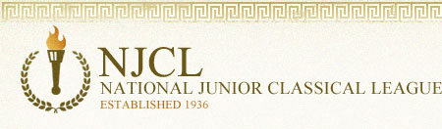
The National Junior Classical League sponsors 3 online exams: Roman Civilization, Classical Etymology, and Latin Vocabulary. This is the 9th year of these challenging contests.

Over 4,700 students took the online Classical Etymology Exam. It was also a 50 question, multiple choice exam. Its purpose is to test a student's knowledge of both Latin and Greek derivatives and their usage in the English language. 40% of Summit students earned awards.

Bronze Medal
Abby Almaguer, Isa Bishop, Maliah Bricking, Zach Davis, Lilly Dwyer, Elizabeth Dziech,
Megan Ebken, Jude Gerhardt, Breanne Grogan, Brandon Harris, Andrew Kahle,
Rimel Kamran, Matthew Langenderfer, Lily Lippert, Owen McEachern, Benny Penote,
Andrew Ritch, Tommy Schaefer, Beckett Schiaparelli, Ryan Schnitter, Jennifer Sullivan,
Maddie Sumnar
Silver Medal
Maria Bishop, Parker Bricking, Ali Burns, Matthew Casanas, Julia Dean, Ethan Lam,
Aidan Lawler, Madison Metzner, Sam Parker, Maddie Sievering, Nicholas Stanis,
Matthew Warden
Gold Medal
Irene Calderon (top Summit score with 40), Jackson Campbell, Jimmy Fraley,
William McLean, Kendall Richard, Kathryn Sullivan

