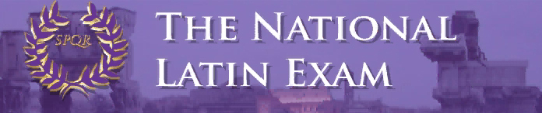

Over 139,000 students from all 50 states and 20 foreign countries participated in the 43rd annual National Latin Exam. The NLE consists of 40 multiple choice questions on grammar, vocabulary, derivatives, mythology, history, and culture. This exam is a chance for students to test their knowledge against Latin students throughout the world. 7th-12th grade Latin students take this exam.

Over 50% of Summit Students Earned Awards, and 11% Earned Gold Medals!

7th Grade Awards – Introduction to Latin Exam (with number correct out of 40)

Achievement Certificate
Drew Hinton (31), Donovan Mathews (33), Logan Miller (34), Benny Penote (34),
David Schnitter (31)

Outstanding Achievement Certificate + Ribbon
Reagan Bricking (38), Jackson Campbell (37), Mia Cavallo (38), C.C. Chavez (37),
Lilly Dwyer (37), Jude Gerhardt (38), Ethan Lam (39), Matthew Langenderfer (38),
Alek Stanisic (35)

8th - 12th Grade Awards (with year of Latin + the number correct out of 40)

‘Cum Laude’ Certificate
Matthew Casanas (III 28), Erin Devine (III 28), Jeffery Huang (IV 25),
Rimel Kamran (I 28), Evan Lakhia (II 27), Kathryn Shaffer (I 28),
Matthew Warden (IV 24)

‘Magna Cum Laude’ Certificate
Graeme Barrere (II 29), Julia Dean (V 32), Megan Ebken (I 31), Cecilia Hasan (II 30),
Margot Lakes (II 30), Maddie Sievering (I 30), Kathryn Sullivan (IV 29)

Silver Medal + ‘Maxima Cum Laude’ Certificate
Abby Almaguer (II 32), Maria Bishop (I 35), Katie Dobelhoff (II 31),
Brandon Harris (V 34), Aidan Lawler (III 31), Lily Lippert (II 31),
Owen McEachern (I 33), William McLane (I 35), Connie Nelson (IV 28),
Kendall Richard (II 34), Hudson Ritch (II 34), Tommy Schaefer (I 33)

Gold Medal + ‘Summa Cum Laude’ Certificate
Isa Bishop (IV 35), Maliah Bricking (IV 38), Ali Burns (I 38), Ryan Burns (IV 40!),
Irene Calderon (II 40!), Jimmy Fraley (II 38), Nicholas Stanis (I 38),
Emily Warden (IV 33)

Perfect Scores on the 2019 NLE

Summit had 2 perfect scores this year! To earn a perfect score is extremely difficult and rare: less than 1% of students received a perfect score on the 2019 National Latin Exam.

- Ryan Burns (Level 4) – 3rd time in 5 years!
- Irene Calderon (Level 2) – 2nd year in a row!

Special Book Awards

The National Latin Exam has awarded a ‘Special Book Award’ to 3 Summit students for earning 4 consecutive gold medals:

- Isa Bishop, Maliah Bricking, and Ryan Burns will receive NLE Book Award, The Oxford Classical Dictionary.

It is an extraordinary achievement to get the Gold Medal numerous times. Grātulātiōnēs!

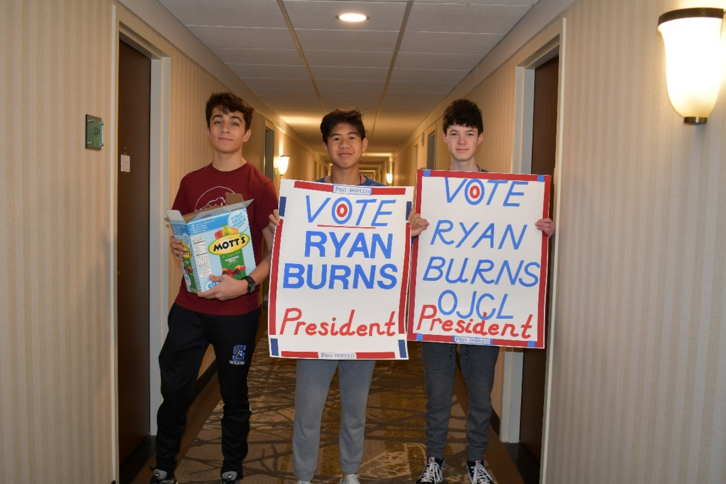
Sophomores (‘wise fools’) Evan, Matthew, and Aidan campaign for their candidate at the state convention!

