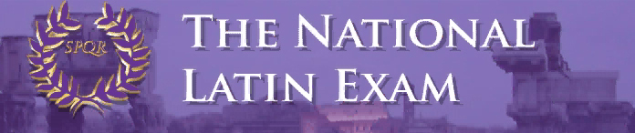

Over 139,000 students from all 50 states and 20 foreign countries participated in the 44th annual National Latin Exam. The NLE consists of 40 multiple choice questions on grammar, vocabulary, derivatives, mythology, history, and culture. This exam is a chance for students to test their knowledge against Latin students throughout the world. 7th-12th grade Latin students take this exam.

70% of Summit Students Earned Awards, and 19% Earned Gold Medals!

7th Grade Awards – Introduction to Latin Exam (with number correct out of 40)

Achievement Certificate
Chike Anusionwu (35), Benedict Domville (34), Lily Gentes (34), Kira Njegovan (33)

Outstanding Achievement Certificate + Ribbon
Anneliese Brouwer (36), Claire Lamarre (37), Kate McLane (39), Maddie Mescher (37),
Sophia Nery (40!), Grace Tounge (36)

8th - 12th Grade Awards (with year of Latin + the number correct out of 40)

‘Cum Laude’ Certificate
Cecilia Hasan (III 25), Rimel Kamran (II 30)

‘Magna Cum Laude’ Certificate
Abby Almaguer (III 27), Graeme Barrere (III 27), Joseph Brecount (I 32),
Parker Bricking (III 27), Matthew Casanas (IV 28), Katie Dobelhoff (III 26),
Elizabeth Dziech (IV 28), Carson Hall (I 33), Andrew Kahle (II 31), Wali Khan (II 32),
Evan Lahkia (III 26), Ana Leyendecker (II 32), Owen McEachern (II 31),
Logan Miller (II 32), Maddie Sievering (II 31), Eli Sparks (I 32)

Silver Medal + ‘Maxima Cum Laude’ Certificate
Ali Burns (II 35), Jackson Campbell (I 36), C.C. Chavez (I 36), Mia Cavallo (I 36),
Erin Devine (IV 32), Lilly Dwyer (I 36), Liliana Friesen (I 35), Jude Gerhardt (I 36),
James Hinton (I 34), Aidan Lawler (IV 31), Alex Rojas (I 36), Maddie Sumnar (I 34)

Gold Medal + ‘Summa Cum Laude’ Certificate
Maliah Bricking (V 37), Reagan Bricking (I 38), Ryan Burns (V 39),
Irene Calderon (III 37), Jimmy Fraley (III 36), Drew Hinton (I 37), Ethan Lam (I 38),
Matthew Langenderfer (I 38), William McLane (II 37), Benny Penote (I 39),
Mia Rahner (I 39), Kendall Richard (III 36), David Schnitter (I 37),
Jennifer Sullivan (III 32), Kathryn Sullivan (V 36)

Perfect Score on the 2020 NLE – Sophia Nery (Intro Level)

To earn a perfect score is extremely difficult and rare: less than 1% of students received a perfect score on the 2020 National Latin Exam.

Special Book Awards

The National Latin Exam will award a ‘Special Book Award’ to 3 Summit students for earning multiple Gold Medals:

- Kathryn Sullivan will receive an NLE Book Award, The Oxford Classical Dictionary, for earning 4 Golds in 5 years.
- Maliah Bricking and Ryan Burns will receive their 2nd NLE Book Award, The Oxford Companion to Classical Literature, for earning 5 consecutive Golds.

