2020 National Mythology Exam

This was the 31st year of the National Mythology Exam. It was taken in February by over 9,000 students from 400 schools in the United States, Canada, and Australia. The goal of the exam is to promote the study of classical mythology and literature in secondary schools. It has 40 (for the 6th grade) or 50 (for the 7th and 8th grades) or 60 (for 9th-12th grades) multiple choice questions. This year's exam had 3 sections:
- the main classical gods & goddesses - Zeus, Athena, Mars, etc
- the story of Perseus – a son of Zeus who is famous for beheading the snaky-haired Gorgon Medusa
- Book 12 of Homer’s Odyssey – Odysseus encounters the Sirens, Scylla & Charybdis, and the island of the Sun-god Helios

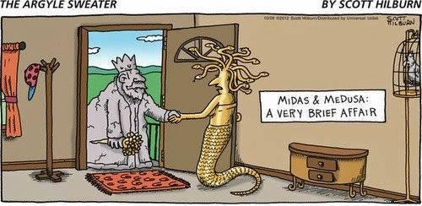
Medusa’s gaze turned people to stone, Midas’ touch turned things to gold!

Ribbon (6th grade only)

Quinn Bohmer
Sydney Brinkman
Jillian Chavez
Ava Dona
Rosie Gieseke
Charles Healy
Sam Hinton
Marcel Huguet
Kadyn Keeney
Cammy Lorentz
Charlie Ritch
Nabil Sinno
Sabian Swan
Claire Wiltshire
Sasha Woodard

Bronze Medallion

6th:
Sophie Brouwer
Katie Buckius
Kenyon Byrd
Allison Ebken
Callie Fox
Callie Karageorges
Kaitlyn Rassi
Ceci Viveros Valdepeña

7th:
Benedict Domville
Claire Lamarre
Kira Njegovan

8th:
Reagan Bricking
Mia Cavallo
C.C. Chavez
Lilly Dwyer
Drew Hinton

Upper School:
Abby Almaguer
Trent Armstrong
Graeme Barrere
Parker Bricking
Ryan Burns
Katie Dobelhoff
Adam Foley
James Hinton
Wali Khan
Aidan Lawler
Lily Lippert
Sam Parker
A.C. Sansalone
Kathryn Shaffer
Eli Sparks

Silver Medallion

6th:
Coleton Chadwell
Hana Conte
Jackson Curt
Caleb Driessen
Zaina Kamran
Connor Schaaf

7th:
Chike Anusionwu
Kate McLane
Sophia Nery

8th:
Carson Hall
Brett Maples
Benny Penote
David Schnitter
Maddie Sumnar

Upper School:
Maliah Bricking
Irene Calderon
Erin Devine
Cecilia Hasan
Margot Lakes
Owen McEachern
William McLane
Mia Rahner
Kendall Richard
Kathryn Sullivan

Gold Medallion – Perfect Exam
Haley Baker (6th grade)
Emily Bolan (6th)
Jackson Campbell (8th)
Meghana Curran (6th)
Aaron Fraley (6th)
Jimmy Fraley (10th)
*3 years in a row!
Jude Gerhardt (8th)
Breanne Grogan (11th)
Ethan Lam (8th)
Matthew Langenderfer (8th)
Ana Leyendecker (9th)
Jennifer Sullivan (10th)
Harper Wood (6th)

