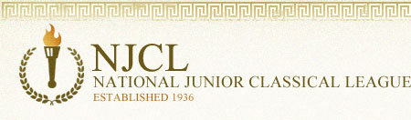
The National Junior Classical League sponsors 3 online exams: Roman Civilization, Classical Etymology, and Latin Vocabulary. This is the 9th year of these challenging contests.

Over 4,000 students took the online Classical Etymology Exam. It was a 50 question, multiple choice exam. Its purpose is to test a student's knowledge of both Latin and Greek derivatives and their usage in the English language. 43% of Summit students earned awards.

Bronze Medal
Abby Almaguer, Maliah Bricking, Parker Bricking, Reagan Bricking, Jackson Campbell,
Erin Devine, Lilly Dwyer, Adam Foley, Cecilia Hasan, Rimel Kamran, Aidan Lawler,
Ana Leyendecker, Kate McLane, Maddie Mescher, Kendall Richard
Silver Medal
Ali Burns, C.C. Chavez, Jude Gerhardt, Ethan Lam, Matthew Langenderfer, Kira Njegovan,
Eli Sparks, David Schnitter, Jennifer Sullivan
Gold Medal
Irene Calderon, Mia Cavallo, Jimmy Fraley (top Summit score), Lily Lippert,
William McLane, Madison Metzner, Sophia Nery, Benny Penote, Mia Rahner, Grace Tounge

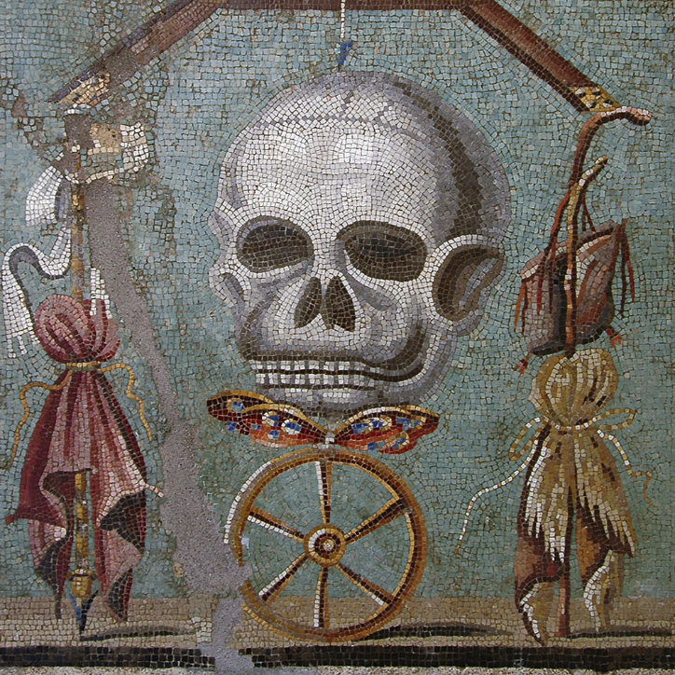
Mosaic from Pompeii with a ‘memento mori’ (remember to die) theme
Over 2,400 students took the online Latin Vocabulary Exam. It was a 70 question, multiple choice exam. Over 26% of Summit students earned an award.

Bronze Medal
Abby Almaguer, Reagan Bricking, Maliah Bricking, Ali Burns, Matthew Casañas,
Elizabeth Dziech, Andrew Kahle, Evan Lakhia, Owen McEachern, William McLane,
Sam Parker, Eli Sparks, Grace Tounge
Silver Medal
Matthew Langenderfer, Kate McLane, Benny Penote, Mia Rahner
Gold Medal
Irene Calderon, Jimmy Fraley (top Summit score), Sophia Nery

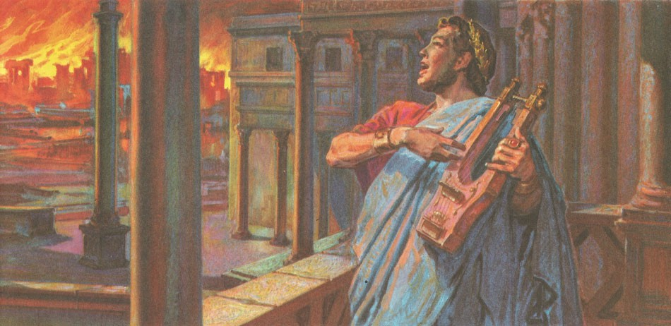
This painting depicts the scene of ‘Nero fiddling while Rome burned.’

Over 1,500 students took the online Roman Civilization Exam. It was a 50 question, multiple choice exam: 25 questions on history, and 25 questions on civilization. Over 36% of Summit students earned an award.

Bronze Medal
Abby Almaguer, Maliah Bricking, C.C. Chavez, Zach Davis, Carson Hall, Cecilia Hasan,
Rimel Kamran, Margot Lakes, Claire Lamarre, Matthew Langenderfer, Owen McEachern,
Madison Metzner, Sophia Nery, Benny Penote, Keenan Schomburger, Kathryn Shaffer,
Kathryn Sullivan, Maddie Sumnar
Silver Medal
Parker Bricking, Reagn Bricking, Irene Calderon, Andrew Kahle, Ethan Lam, Mia Rahner,
Kendall Richard
Gold Medal
Jimmy Fraley (top Summit score)

Nōtā Bene: Irene, Jimmy, and Sophia all earned at least 2 Golds on the 3 NJCL Online Exams, which makes them eligible to win cash awards!

