On Sat Sept 23, over 50 students from 10 Cincinnati schools participated in the Moeller Open Certamen. 8 Summit students competed: Abby Almaguer, Irene Calderon, Patrick Casanas, Jimmy Fraley, Caroline Klette, Kendall Richard, James Speed, and Jennifer Sullivan.
4 Summit Latin students made it to the 3-team Final Round. Nice work!
- Irene Calderon – 3rd place, Novice
- Jimmy Fraley – 1st place, Novice
- Kendall Richard – 2nd place, Novice
- James Speed – 1st place, Advanced

******************************************************************************************
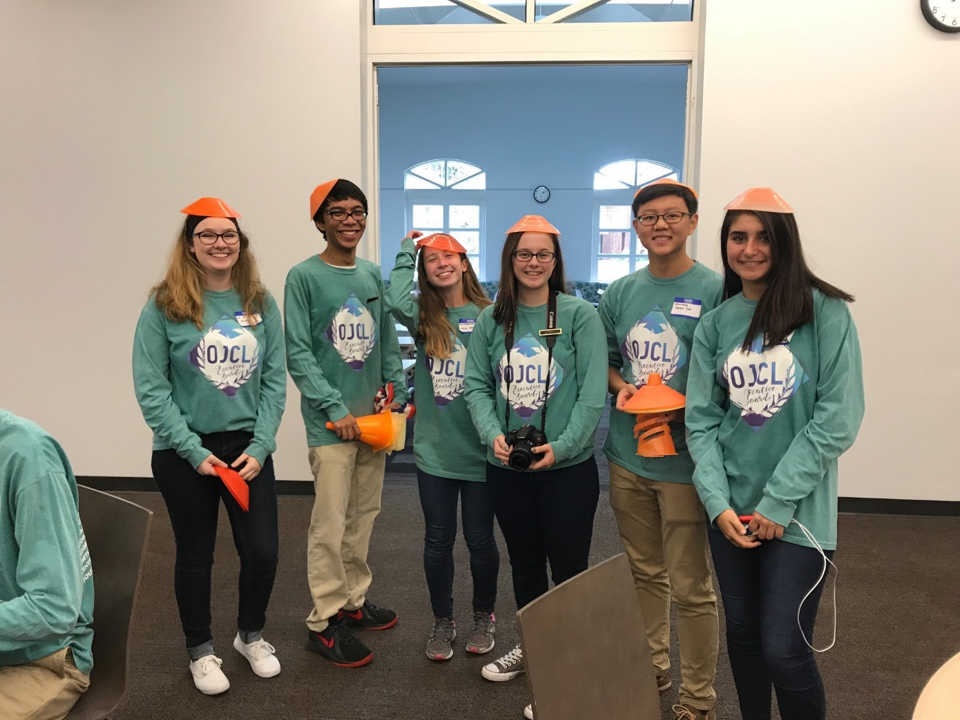
Caroline, Joseph, Julia with some of the OJCL Leadership!

On Sat Oct 7, 17 Summit students joined 30 other Cincinnati area Latin students on a bus to the 2nd Annual Fall Forum at Columbus Academy. Over 100 students in total attended this activity-packed 1-day event. It is organized by the OJCL Executive Board, and Summit has 3 student officers who are part of this leadership team: President Joseph Delamerced, 1st Vice-President Caroline Klette, and Parliamentarian Julia Dean.
Here is the basic schedule:
- 9:30-10:20 – Lecture on the Pantheon and its huge dome
- 10:20-10:45 – Opening General Assembly
- 10:45-11:45 – Various Colloquia (how to become at officer, what is state convention, how to build your own loom, etc.)
- 11:45-12:30 – Academic Test! (it was quite hard, next year’s will be easier…)
- 12:30-1:15 – Pizza Lunch
- 1:15 – 2:15 – OJCL Ludi – either Capture the Flag or Ultimate Frisbee or Athens Besieged (historical game simulation)
- 2:15 – 3:30 – Open Certamen!
- 3:30 – 4:30 – either Creative Arts Competition (English Oratory/Latin Sight Reading) or Impromptu Art (based on the 2018 convention theme from Vergil, Audentes Fortuna iuvat, ‘Fortune favors the bold!’)
- 4:30 – 5:00 – Closing General Assembly & Awards
Who Went?
MS
- Abby Almaguer
- Parker Bricking
- Jimmy Fraley
- Owen McEachern
- Kendall Richard
- Jennifer Sullivan
- Teddy Sumnar

US
- Isa Bishop
- Maliah Bricking
- Patrick Casanas
- Davis DeFoor
- Julia Dean
- Joseph Delamerced
- Erin Devine
- Caroline Klette
- Ava Norton
- James Speed

Awards!
MS
- Abby Almaguer – 2nd in Novice Certamen, 2nd in English Oratory, 3rd in Latin Sight Reading, 5th on Latin 1 Academic Test
- Parker Bricking – 2nd in Novice Certamen
- Jimmy Fraley – 1st in Novice Certamen, 2nd in Latin 1 Academic Test
- Owen McEachern – 3rd in Novice Certamen
- Kendall Richard – 1st in Latin 1 Academic Test
- Jennifer Sullivan – 2nd in Novice Certamen, 2nd in Latin 1 Academic Test

US
- Isa Bishop – 2nd in Latin 3 Academic Test
- Maliah Bricking – 2nd in Latin 3 Academic Test
- Davis DeFoor – 1st in English Oratory, 3rd in Latin Sight Reading, 3rd in Advanced Certamen
- Joseph Delamerced – 3rd in Advanced Certamen, 4th in Latin 4+ Academic Test
- Erin Devine – 1st in Intermediate Certamen, 3rd on Latin 2 Academic Test
- Caroline Klette – 2nd in Advanced Certamen, 4th on Latin 4+ Academic Test
- James Speed – 3rd in Advanced Certamen

a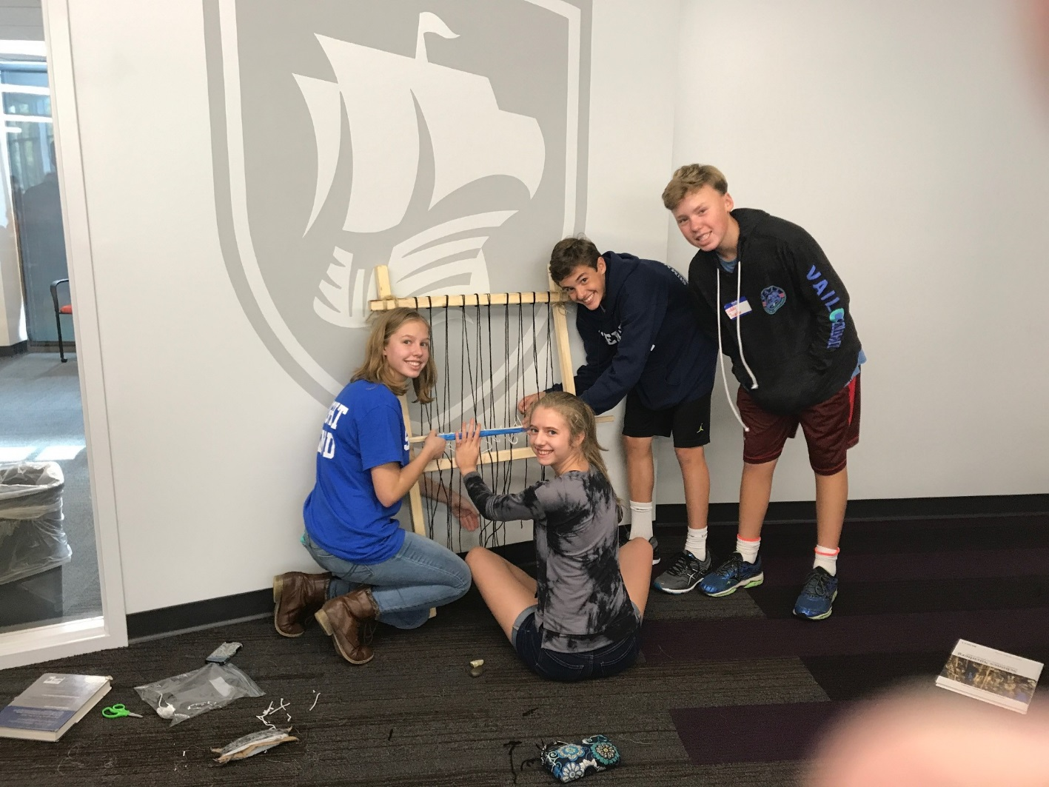
Maliah, Jennifer, Parker, and Teddy working on their loom
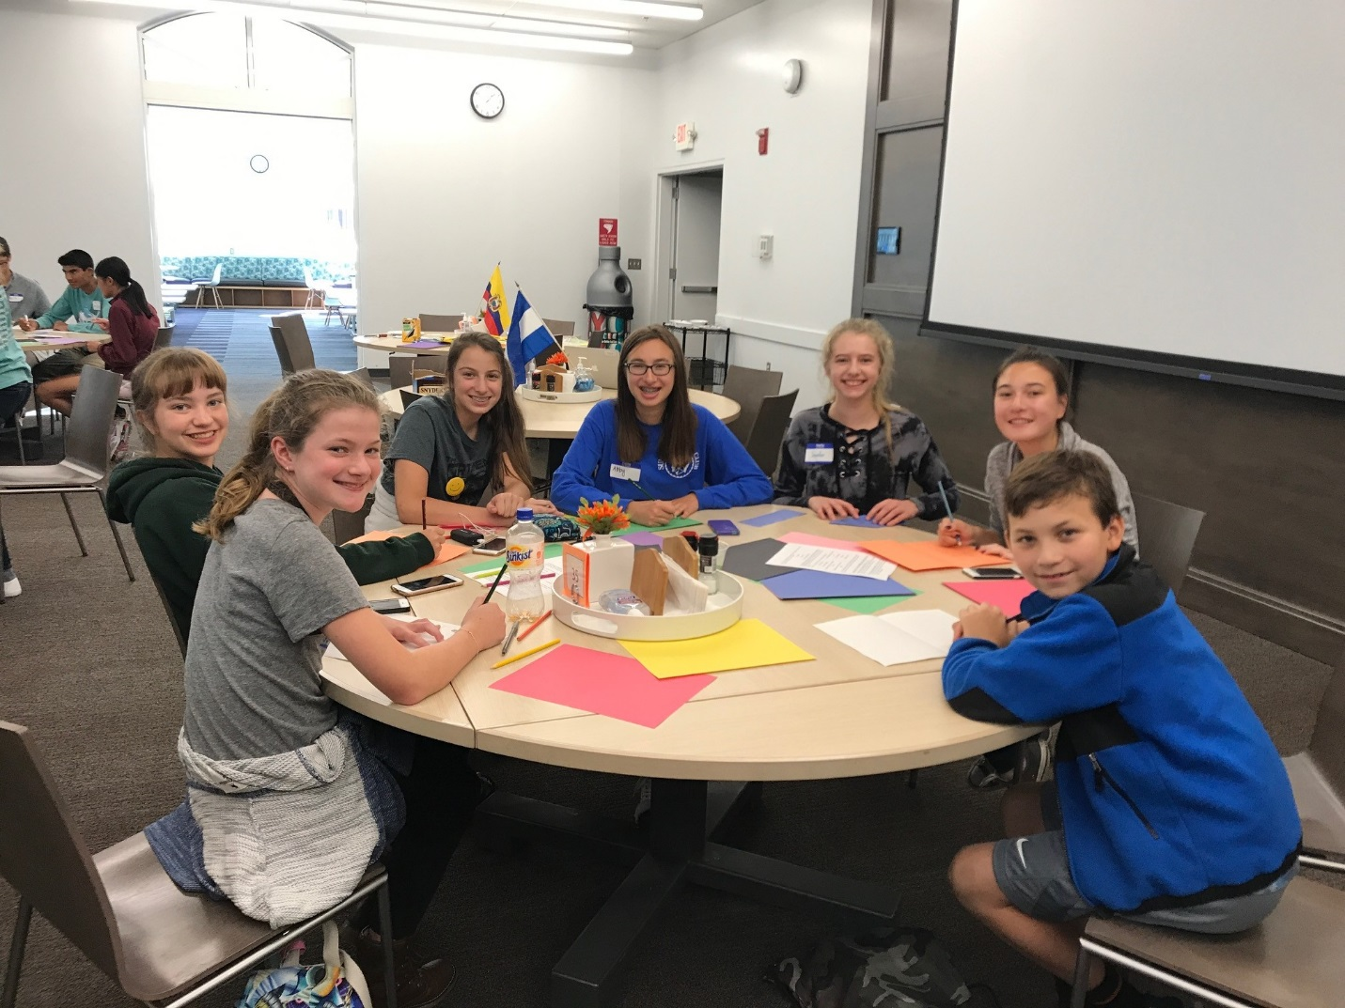
Impromptu Art!

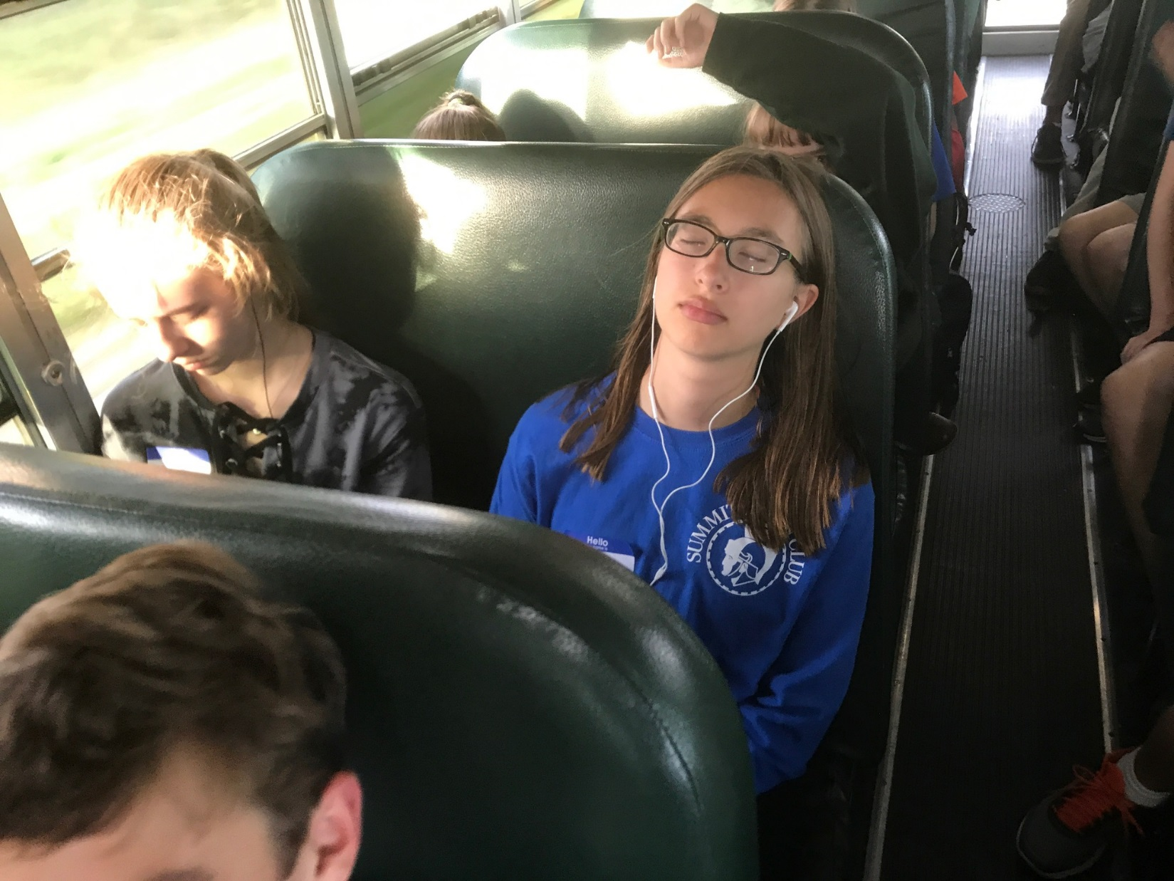
The bus ride home…

