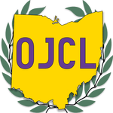

North MADD:
Horseshoe Lake Park Cleanup

Sunday October 30th, 2016 1-4 PM

17499 South Park Blvd (stay left up Park Drive)
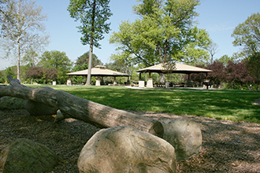

Wear warm, comfortable clothes and get ready to make the park shine! Bring a fun attitude and OJCL spirit!

Gloves and trash bags will be provided, along with pizza and drinks for a small picnic.
We’ll meet at the Large Pavilion past the playground

See you there!

