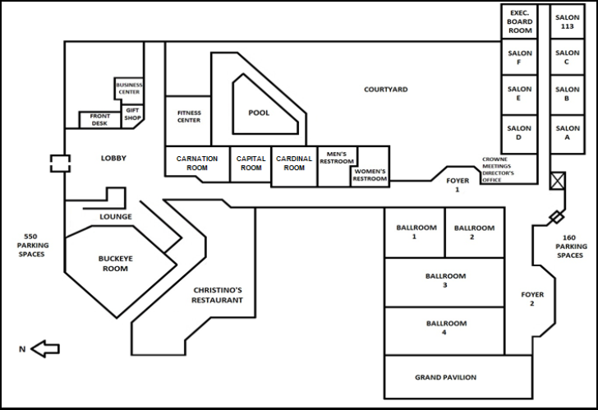

**HALLWAY THROUGH BEDROOMS TO ELEVATOR ACCESS FLOORS 1-8**

**FOYER**

**2**

**FOYER**

**1**

**BALLROOM**

**4**

**BALLROOM**

**3**

**BALLROOM**

**2**

**BALLROOM**

**1**

**CHRISTINO’S RESTAURANT**

**GRAND PAVILION**

**BUCKEYE ROOM**

**EXEC**

**BOARD**

**ROOM**

**SALON**

**113**

**SALON**

**C**

**SALON**

**F**

**SALON**

**B**

**SALON**

**E**

**SALON**

**A**

**SALON**

**D**

**CAPTIAL ROOM**

**OHIO ROOM**

**CARDINAL ROOM**