2018-2019 Medusa Mythology Exam
The Medusa Mythology Exam is a 40 question multiple-choice test given every November to over 10,000 high school students from across the United States. This exam is much more challenging than the National Mythology Exam and requires a thorough knowledge of Greek mythology.
The theme of this year’s competition was ‘Where have all the heroes gone?’ It emphasized famous heroes, the places they visited, and what they did there. Examples include: Odysseus, his adventure in the Underworld, and his conversation with the prophet Tiresias; Aeneas, his stop in Carthage, and Dido’s suicide when he departed for Italy; and Hercules, his 1st Labor at Nemea, and his killing of the Nemean Lion.
36% of Summit students earned an award this year.

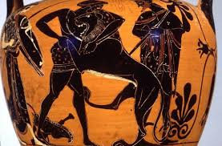

This Greek red-figure vase painting shows Hercules wrestling the Nemean Lion.

‘Corona Olivae’ Certificate – Maria Bishop, Isa Bishop, Parker Bricking, Julia Dean, Katie Dobelhoff, Adam Foley, Brandon Harris, Cecilia Hasan, Burke Hinton, Wali Khan, Evan Lakhia, Owen McEachern, Morgan Nuss, Hudson Ritch, Maddie Sumnar

‘Corona Laurea’ Certificate – Abby Almaguer, Maliah Bricking, Ryan Burns, Jude Gerhardt, Drew Hinton, Ryan Schnitter

Bronze Medal – Jackson Campbell, Nicholas Stanis, Jennifer Sullivan

Silver Medal – Jimmy Fraley, Kendall Richard

Gold Medal - Irene Calderon (36 correct)

