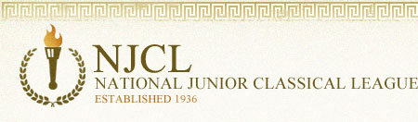
The National Junior Classical League sponsors 3 online exams: Roman Civilization, Classical Etymology, and Latin Vocabulary. This is the 9th year of these challenging contests.

Over 4,600 students took the online Classical Etymology Exam. It was also a 50 question, multiple choice exam. Its purpose is to test a student's knowledge of both Latin and Greek derivatives and their usage in the English language. 40% of Summit students earned awards.

Bronze Medal
Abby Almaguer, Isa Bishop, Maliah Bricking, Zach Davis, Lilly Dwyer, Elizabeth Dziech,
Megan Ebken, Jude Gerhardt, Breanne Grogan, Brandon Harris, Andrew Kahle,
Rimel Kamran, Matthew Langenderfer, Lily Lippert, Owen McEachern, Benny Penote,
Andrew Ritch, Tommy Schaefer, Beckett Schiaparelli, Ryan Schnitter, Jennifer Sullivan,
Maddie Sumnar
Silver Medal
Maria Bishop, Parker Bricking, Ali Burns, Matthew Casanas, Julia Dean, Ethan Lam,
Aidan Lawler, Madison Metzner, Sam Parker, Maddie Sievering, Nicholas Stanis,
Matthew Warden
Gold Medal
Irene Calderon (top Summit score with 40), Jackson Campbell, Jimmy Fraley,
William McLean, Kendall Richard, Kathryn Sullivan

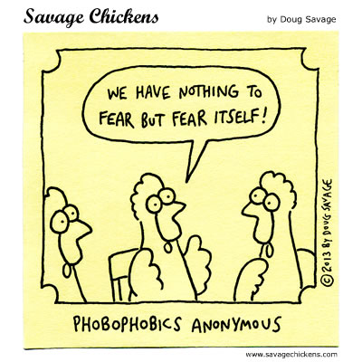
Over 2,300 students took the online Latin Vocabulary Exam. It was a 70 question, multiple choice exam. Over 25% of Summit students earned an award.

Bronze Medal
Abby Almaguer, Maliah Bricking, Ryan Burns, Michelle Chen, Megan Ebken, Jimmy Fraley,
Brandon Harris, Rimel Kamran, Ethan Lam, Connie Nelson,Kendall Richard,
Hudson Ritch, Jennifer Sullivan, Nicholas Stanis, Emily Warden
Silver Medal
Parker Bricking, Ali Burns, Cecilia Hasan, Owen McEachern, William McLane,
Benny Penote, Kathryn Sullivan,
Gold Medal
Irene Calderon

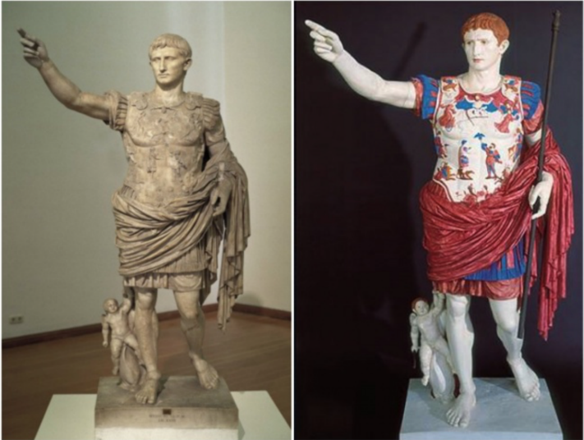
On the left is the original statue of Augustus (called Prima Porta since it was discovered there). On the right is a possible reconstruction which shows the vibrant colors that were common on ancient sculpture and temples.

Over 1,500 students took the online Roman Civilization Exam. It was a 50 question, multiple choice exam: 25 questions on history, and 25 questions on civilization. Over 25% of Summit students earned an award.

Bronze Medal
Abby Almaguer, Maliah Bricking, Parker Bricking, Matthew Casanas, Adam Foley,
Brandon Harris, Owen McEachern, Logan Miller, Kendall Richard, Hudson Ritch,
Tommy Schaefer, Beckett Schiaparelli, Benjamin Schmerge, Maddie Sievering, Alek Stanisic, Isha Tamrakar
Silver Medal
Irene Calderon, Michelle Chen, Matthew Langenderfer, Willam McLane, Nicholas Stanis
Gold Medal
Jimmy Fraley

Nōtā Bene: Irene and Jimmy earned 2 Golds on the 3 NJCL Online Exams, which makes them eligible to win cash awards!

