2019 Exploratory Latin Exam

Over 1000 students from 24 states competed in the 15th annual Exploratory Latin Exam. Its purpose is to promote enthusiasm for the classical world in elementary and middle schools. The ELE is a 50 question multiple choice exam on derivatives, Roman life, mythology, art & architecture, etc. This year’s exam included 10 ‘special topic’ questions on ‘Ancient Geography.’
Questions included:
- If your teacher said, ‘ambula ad ianuam!’, what should you do? (walk to the door)
- Aures audiunt. _____ plaudunt. (manus)
- Ubi est Alexandria? (in Aegypto)

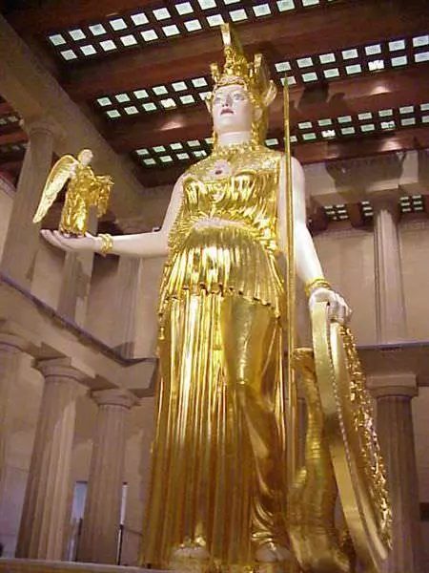

Reconstruction of the statue of Athena Parthenos in Nashville TN:
Athens, the birthplace of democracy, is the location of the Parthenon, the temple dedicated to Athena, the city’s patron deity. The warrior goddess holds Nike, the personification of Victory in her right hand.

‘Cum Laude’ Certificate + Ribbon (40+):
Mason Butler, Lily Gentes, Brenden Hamilton, Claire Lamarre, Grace Tounge

‘Magna Cum Laude’ Certificate + Ribbon (44+):
Colin Koran, Jocelyn Lauckner, Jordyn Lauckner, Kira Njegovan, Anna Grace Sanders, Elena Stone

‘Summa Cum Laude’ Certificate + Ribbon (47+): Joey DiPaola, Sophia Nery

‘Summa Cum Laude’ Certificate + Gold Medal (a perfect 50!): Katie McLane

