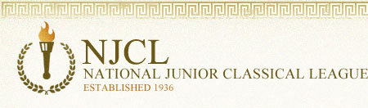

Over 3,600 students took the online Classical Etymology Exam. It was a 50 question, multiple choice exam. Its purpose is to test a student's knowledge of both Latin and Greek derivatives and their usage in the English language. 43% of Summit students earned awards.

Bronze Medal
Haley Baker, Hana Conte, Kanai Gillispie, Rylee Jewell, Landon Miller, Liv Mueller,
Sam Parker, Benny Penote, Charlie Rahner, Grace Sabath, Johnny Sumnar, Cailyn Youtsey
Silver Medal
Jack Baker, Olivia Beltran, Emily Bolan, Jefferson Campbell, Kyan Gatewood, Tyler Gier,
Bennett Kreeger, Andrew Lam, Ana Leyendecker, Collin McGuire, Abigayle Penote,
Madelyn Smith, Kat Shuey
Gold Medal
Danny Beyerbach, Manu Cantillo, Aaron Fraley, Ben Hofmann, Kori McLane,
Shriyan Masineni, Sophia Nery, Mia Rahner (top Summit score!), John Trokan

1,277 students took the online Roman Civilization Exam. It was a 70 question, multiple choice exam. 17% of Summit students earned an award.

Bronze Medal
Olivia Beltran, Callie Fox, Kyan Gatewood, Tyler Gier, Sophia Nery, Harper Wood,
Cailyn Youtsey
Silver Medal
Aaron Fraley, Ben Hofmann, Shriyan Masineni, Kori McLane,
Mia Rahner (top Summit score!), John Trokan

