2024 Pegasus Mythology Exam

The Pegasus Mythology Exam is a multiple-choice test given every February to over 5,000 middle school students from over 300 schools across the United States. This exam includes the origins of the classical gods, the rule of the Olympians, and a special section on Heracles and his 12 Labors.

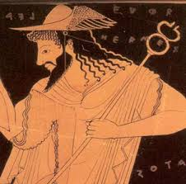
A red-figure vase painting of the messenger god Hermes with his winged hat and his staff called the caduceus.

The 6th graders took a 40-question test, and 51% earned an award this year.

‘Cum Laude’ Certificate (29-34):
Rachel Burkart, Maddie Burns, Andrew Caldwell, Sabrina Diaz, Elise Goebel,
Eliana Hafner, RJ Johnson, Owen Lee, Izze Montaque, Estelle Neyer, Madie Richard,
Molly Sullivan, Evan Williams

Ribbon + ‘Magna Cum Laude’ Certificate (35):
Lily Finkleman, Emma McCormick, Andrea Perez Sanchez, Teagan Wood

Silver Medal + ‘Maxima Cum Laude’ Certificate (36-38):
EJ Clements, Tuula Hicks, Evelyn Paulsen, Rebeca Perez Sanchez

Gold Medal + ‘Summa Cum Laude’ Certificate (39-40):
Anna Baker (Perfect Score!), James Finkleman, Sophia Lei (Perfect Score!),
Hudson Pfeffer (Perfect Score!), Emma Rinehart
The 7th and 8th graders took a 50-question test. It included the 40 questions from the 6th grade exam with 10 more detailed questions on Heracles and his 12 Labors.

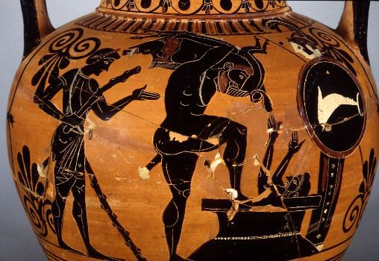
In this black-figure vase painting, Heracles shows the Erymanthian boar to his taskmaster Eurystheus,
who is cowering in a large storage jar.

68% of Summit 7th and 8th graders earned an award this year.

‘Cum Laude’ Certificate (34-39):
Jack Baker, Liam Kenney, Landon Miller

Ribbon + ‘Magna Cum Laude’ Certificate (40-42):
Van Devendorf, Kyan Gatewood, John Trokan

Silver Medal + ‘Maxima Cum Laude’ Certificate (43-46):
Colton Bettcher, Charlie Jenkins, Stefen Karageorges, Bennett Kreeger, Samuel Krulcik,
Olivia Miele, Enya Renfrow, Ari Symonds

Gold Medal + ‘Summa Cum Laude’ Certificate (47-50):
Olivia Beltran, Ben Hofmann (perfect score!), Cameron Kline, Sofia Pancheri,
Alejandro Sharp

