2024 Exploratory Latin Exam

730 students competed in the 20th annual Exploratory Latin Exam. Its purpose is to promote enthusiasm for the classical world in elementary and middle schools. The ELE is a 50-question multiple choice exam on derivatives, Roman life, mythology, art & architecture, etc. This year’s exam included 10 ‘special topic’ questions on ‘Geography of the Ancient Mediterranean.’ About 30% of Summit 6th graders earned an award.

Questions included:
- What is the opposite of salvē? (valē)
- Which animal lives in water? (piscis)
- Ubi Cleopatra rēgīna erat? (Aegyptus)

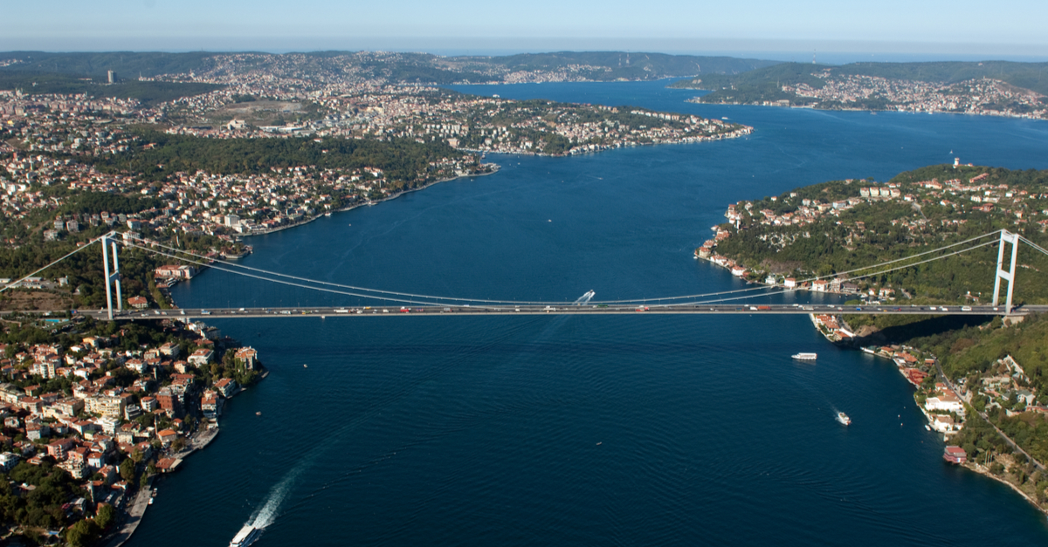
The Bosporus is the strait at the mouth of the Black Sea in Istanbul, Turkey. The former name of Istanbul was Constantinople, the ‘city of Constantine’ in the Roman province Asia Minor.

‘Cum Laude’ Certificate + Ribbon (35-39):
Callie Chadwell, Sabrina Diaz, Eliana Hafner,Tuula Hicks, Connor Love,
Evelyn Paulsen, Madie Richard, Teagan Wood

‘Magna Cum Laude’ Certificate + Ribbon (40-46):
James Finkleman, Mia Gehring, Sophia Lei, Andrea Perez Sanchez,
Rebeca Perez Sanchez (top Summit score!), Emma Rinehart

