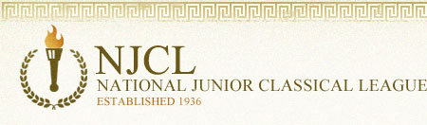

Over 3,400 students took the online Classical Etymology Exam. It was a 50 question, multiple choice exam. Its purpose is to test a student's knowledge of both Latin and Greek derivatives and their usage in the English language. 43% of Summit students earned awards.

Bronze Medal
Haley Baker, Van Devendorf, Drew Fletcher, Delaney Kintner, Ethan Lam, Brett Maples,
Landon Miller, Lorenzo Rose, Charlotte Thompson
Silver Medal
Alina Butcher, Callie Fox, Alexis Lange, Kori McLane, Olivia Miele, Alejandro Sharp,
John Trokan, Daniel Winhusen
Gold Medal
Olivia Beltran, Aaron Fraley, Kyan Gatewood, Ben Hofmann,
Rowan Lavelle (top Summit score!), Shriyan Masineni

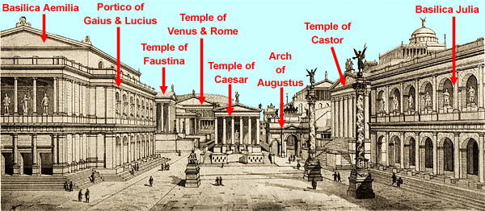
Every ancient Roman city had a forum (marketplace/gathering space). The most famous is the Forum Romanum in Rome itself. A forum had government buildings, temples, law court, shops, and a meeting place.

Over 1,200 students took the online Roman Civilization Exam. It was a 70 question, multiple choice exam. 18% of Summit students earned an award.
Bronze Medal
Chike Anusionwu, Christian Basler, Hana Conte, Callie Fox, Kyan Gatewood, Alexis Lange,
Kori McLane, Olivia Miele
Silver Medal
Emily Bolan, Shriyan Masineni, John Trokan
Gold Medal
Aaron Fraley (top Summit score!), Ben Hofmann

Over 1,800 students took the online Latin Vocabulary Exam. It was a 70 question, multiple choice exam. 28% of Summit students earned an award.
Bronze Medal
Hana Conte, Kyan Gatewood, Charlie Jenkins, Rowan Lavelle,
Shriyan Masineni, Olivia Miele
Silver Medal
Van Devendorf, Zezzie Imperial, Kori McLane, Alejandro Sharp, John Trokan
Gold Medal
Ben Hofmann (who was 1 of 5 Latin students to earn a perfect score!)

Over 300 students took the online Hellenic Civilization Exam. It was a 50 question, multiple choice exam on all aspects of ancient Greek language, culture, history, and literature. 12% of Summit students earned an award.
Bronze Medal
Aaron Fraley, Zaina Kamran, Bennett Kreeger, Stefen Karageorges, Maddie Mescher,
John Trokan

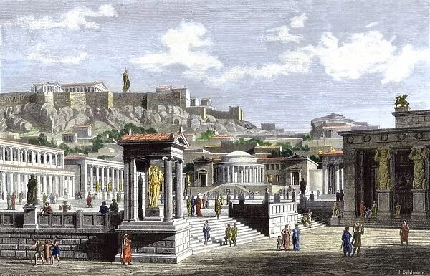
The agora was the ancient Greek equivalent of the forum of Roman cities.
This is a reconstruction of the agora in Athens.

