**2025 Pegasus Mythology Exam**

The Pegasus Mythology Exam is a multiple-choice test given every February to over 5,400 middle school students from across the United States. This exam includes the origins of the classical gods, the rule of the Olympians, and a special section on ‘Ancient Beginnings.’

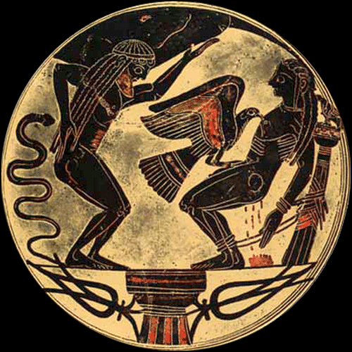

*A black-figure drinking cup with Atlas holding up the earth and Prometheus being tortured by an eagle sent from Zeus.*

The **6th graders** took a 40-question test, and **50%** earned an award this year.

**‘Cum Laude’ Certificate (31-35)**:

Macey Adams, Tristan Dona, AJ Gray, Houston Griffin, Luke Jenkins, Henry Knepfle,

Sydney Koo, Alex Mulvihill, David Patino, Alex Pearce, Noah Roberts, Carrigan Sams,

Emi Spreen, Gwen Suder, Natalya Wangler

**Ribbon + ‘Magna Cum Laude’ Certificate (36-37)**:

Elliot Fox, Evan Fox, Luke Haughaboo-Giannella, Alex Norng, Millie Rich, Liam Roberts,

Regis Rogers, Russell Roth, Ivy Sousa, Lauren Mueller

**Silver Medal + ‘Maxima Cum Laude’ Certificate (38)**:

Ava Maly, Dean Mohan, Ryan Schaaf, Hailey Wise

**Gold Medal + ‘Summa Cum Laude’ Certificate (39-40):**

Michaela Bell (Perfect Exam!), Evan Gockerman, Matti Hofmann,

Sophie Pressey

The **7th and 8th graders** took a 50-question test. It included the 40 questions from the 6th grade exam with 10 more detailed questions on ‘Ancient Beginnings. ‘



*Pandora opened a forbidden box and released evils into the world.*

***82% of Summit 7th and 8th graders earned an award this year.***

**‘Cum Laude’ Certificate (34-39)**:

Rachel Burkart, Elise Goebel

**Ribbon + ‘Magna Cum Laude’ Certificate (43-45)**:

EJ Clements, Lily Finkleman, Mia Gehring

**Silver Medal + ‘Maxima Cum Laude’ Certificate (46-47):**

Van Devendorf, Olivia Miele, Sofia Pancheri, Emma Rinehart, Andrea Perez Sanchez,

Rebeca Perez Sanchez, Ari Symonds

**Gold Medal + ‘Summa Cum Laude’ Certificate (48-50)**:

James Finkleman, Charlie Jenkins (top Summit score!), Stefen Karageorges,

Cameron Kline, Sophia Lei, Hudson Pfeffer (top Summit score!)