[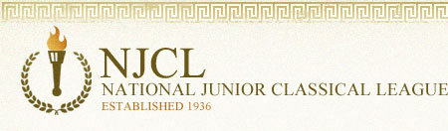](http://njcl.org/)

2,815 students took the online **Classical Etymology Exam**. It was a 50 question, multiple choice exam. Its purpose is to test a student's knowledge of both Latin and Greek derivatives and their usage in the English language. 64% of Summit students earned awards.

**Bronze Medal**

Maddie Burns, Livia Butcher, Lowry Cavanaugh, Rowan Cosgrove, Ben Dobelhoff,

Kyan Gatewood, Mia Gehring, Zaina Kamran, Stefen Karageorges, Natalie Kenter,

Cameron Kline, Alexis Lange, Collin McGuire, Olivia Miele, Liv Mueller, Charlie Rahner,

Madie Richard, Daniel Winhusen, Adelynn Woodward

**Silver Medal**

Emily Bolan, Manu Cantillo, Van Devendorf, James Finkleman, Callie Fox, Zezzie Imperial,

Delaney Kintner, Sophia Lei, Evelyn Paulsen, Emma Rinehart, Rebeca Perez Sanchez,

Ari Symonds, John Trokan

**Gold Medal**

Hana Conte, Aaron Fraley (top Summit score!), Rowan Lavelle, Kori McLane,

Sofia Pancheri, Hudson Pfeffer, Andea Perez Sanchez

1,068 students took the online **Roman Civilization Exam**. It was a 70 question, multiple choice exam. 45% of Summit students earned an award.

**Bronze Medal**

Emily Bolan, Van Devendorf, James Finkleman, Kyan Gatewood, Mia Gehring,

Kendall Jones, Sophia Lei, Zaina Kamran, Kadyn Keeney, Rowan Lavelle,

Olivia Miele, Liv Mueller, Corbin Nuss, Sofia Pancheri, Evelyn Paulsen,

Rebeca Perez Sanchez, Runako Muvirimi

**Silver Medal**

Hana Conte, Lily Finkleman, Callie Fox, Aaron Fraley (top Summit score!),

Stefen Karageorges, Kori McLane, Emma Rinehart, John Trokan

**Gold Medal**

EJ Clements, Andrea Perez Sanchez

Over 2,000 students took the online **Latin Vocabulary Exam**. It was a 70 question, multiple choice exam. 29% of Summit students earned an award.

**Bronze Medal**

Manuel Cantillo, EJ Clements, Callie Fox, Mia Gehring, Kyndall Jones, Zaina Kamran,

Rowan Lavelle, Sophia Lei, Kori McLane, Sofia Pancheri, John Trokan

**Silver Medal**

Rachel Burkart, Van Devendorf, Kyan Gatewood, Evelyn Paulsen, Hudson Pfeffer,

Emma Rinehart, Andrea Perez Sanchez, Rebeca Perez Sanchez

Over 300 students took the online **Hellenic Civilization Exam**. It was a 50 question, multiple choice exam on all aspects of ancient Greek language, culture, history, and literature. 20% of Summit students earned an award.

**Bronze Medal**

Lily Fecher, Callie Fox, Miles Friedman, Kyndall Jones, Shriyan Masineni, Collin McGuire,

Grace Tounge, Adelynn Woodward

**Silver Medal**

Tofunmi Ajayi, Will Fox, Stefen Karageorges, Sophia Lei, John Trokan

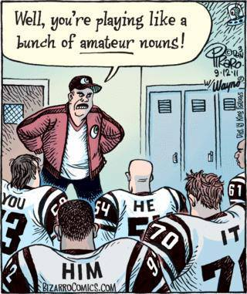

Grammar humor is the bestest.