**2025 Exploratory Latin Exam**

Over 800 students competed in the 21st annual Exploratory Latin Exam. Its purpose is to promote enthusiasm for the classical world in elementary and middle schools. The ELE is a 50-question multiple choice exam on derivatives, Roman life, mythology, art & architecture, etc. This year’s exam included 10 ‘special topic’ questions on ‘Ancient Roman Entertainment.’ 35% of Summit 6th graders earned an award!

Questions included:

* I am a fīlius. I have duo fratrēs and ūna soror. How many līberī do my parentēs have? quattuor
* Which color is made when flavus and caeruleus are mixed together? prasinus
* Aquila was a gladiator who fought with a net. What type of gladiator was he? rētiārius

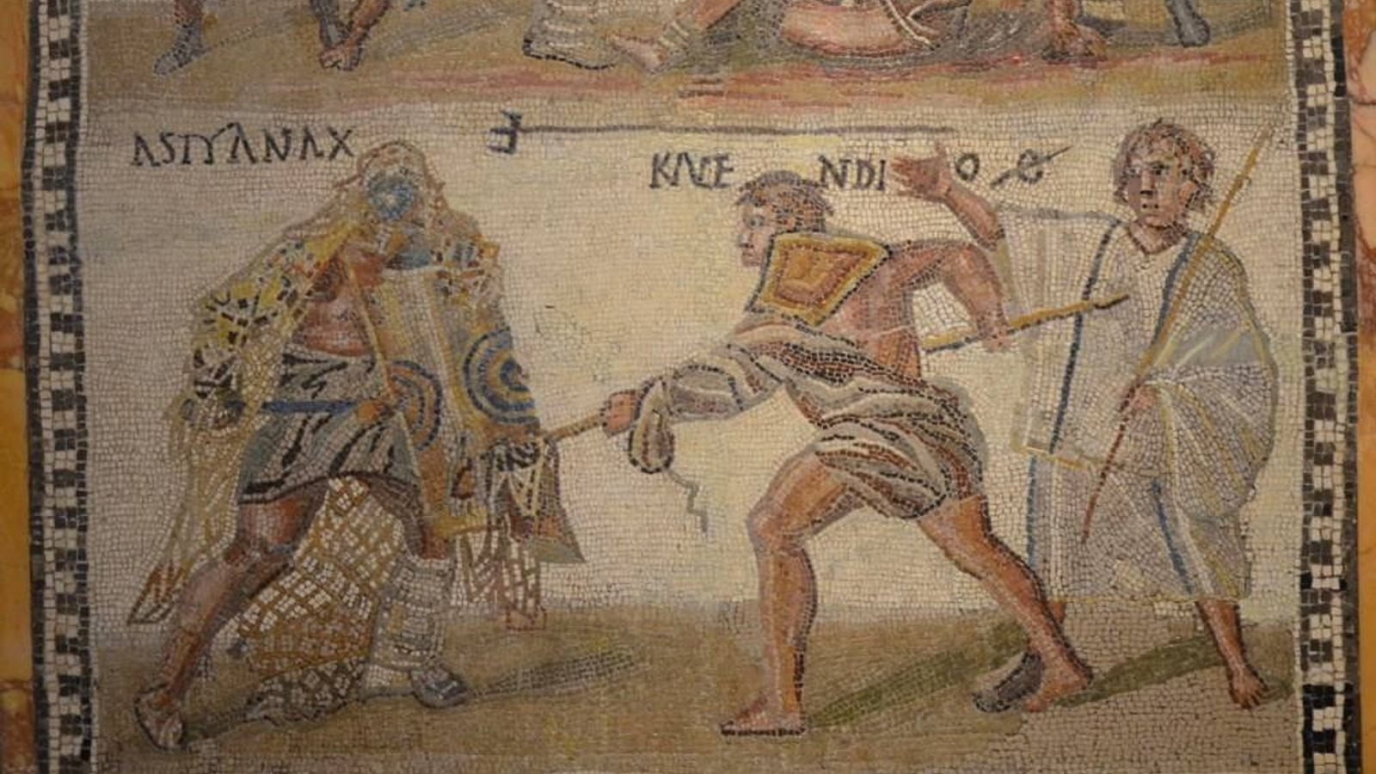

*This mosaic shows the rētiārius Kalendio fighting the secūtor Astyanax. Kalendio has thrown his net over Astyanax and is trying to injure him with his trident. The person to the right with a stick is the referee. Contrary to the popular belief, most matches did not go to the death.*

**‘Cum Laude’ Certificate + Ribbon (35-39)**:

Michaela Bell, Lilly Curt, Tristan Dona, Ruby Hayes, Henry Knepfle,

Dean Mohan, Noah Roberts, Alex Norng, Ryan Schaaf, Carrigan Sams,

Ivy Sousa, Gwen Suder

**‘Magna Cum Laude’ Certificate + Ribbon (40-45)**:

Chelsea Beyerbach, Matti Hofmann, Sophie Pressey, Millie Rich,

Russell Roth, Sydney Koo, Hailey Wise

**‘Summa Cum Laude’ Certificate + Ribbon (47-49):** Liam Roberts