
The Department of Classics and the Classics Club at the University of Cincinnati...

November 8, 2025
“Saevit medio in certamine Mavors”
-Vergil’s Aeneid 8.700

If you have any further questions, please contact Kelly Shannon-Henderson at shannoko@ucmail.uc.edu
Where: University of Cincinnati, West Campus Building: Arts and Sciences building, Check-in at Room 127
When: November 8, 2025 9:00-9:30 Registration
9:45 Three round-robin style rounds 11:15 Finals
12:00 UC Classics welcome with Pizza and Awards

How Do I Get There? Directions to get to campus in general: https://www.uc.edu/about/maps.html

If simply dropping off students by car or bus:
- Enter McMicken Circle from Clifton Ave. - the entrance is at the light next to UC Law, across the street from Hughes High School. It is marked by the flag-pole.
- Drop students off along the second half of McMicken Drive, as it slopes downhill. Continue down the hill to leave, or to get to Clifton Court Parking Garage - directions for parking are below.
- The Arts and Sciences building is the one with the lion statues in front of it, it is to the left of the fountain. If you walk past the lion statues, enter the doors to the right and go to Room 127 for check-in.
If you're planning on staying and need to park:
- On Clifton Ave., turn onto Clifton Court Drive. This street is directly across the street from the Delta Tau Delta house.
- Continue down Clifton Court drive until you come to a three-way split - take the middle road to enter Clifton Court Garage, park there. (Parking in this garage can cost $7-$10.)
- The staircase to the right of the entrance (from the perspective of entering the garage) to the garage leads up to a hill. A large red brick building will be to your right, it will be up another hill, this is the Arts and Sciences building.
- Once you walk up the stairs in front of the Arts and Sciences building, enter the doors to the left and go to Room 127 for check-in.

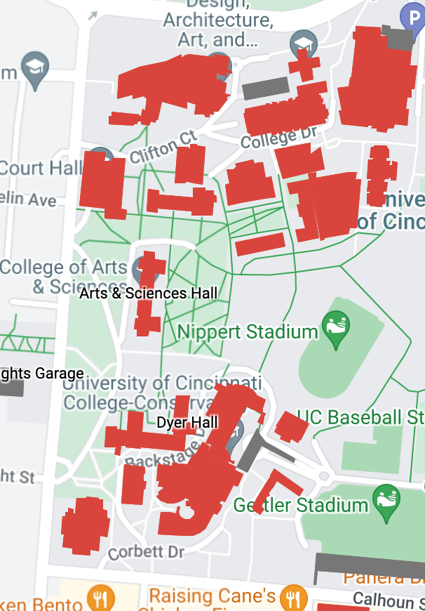
Clifton Court Garage
Arts & Sciences Hall
Parking Entrance
Drop-off Entrance

