2026 Medusa Mythology Exam

The Medusa Mythology Exam is a 40-question multiple-choice test given every April to over 1,800 high school students across the United States. This exam is challenging and requires a thorough knowledge of Greek mythology. The theme of this year’s competition was ‘Game of Thrones: Olympian Edition’ This year’s theme focused on focuses on the power struggles and rivalries that frequently shape the relationships among the Olympian gods.
23% of Summit students earned an award this year.

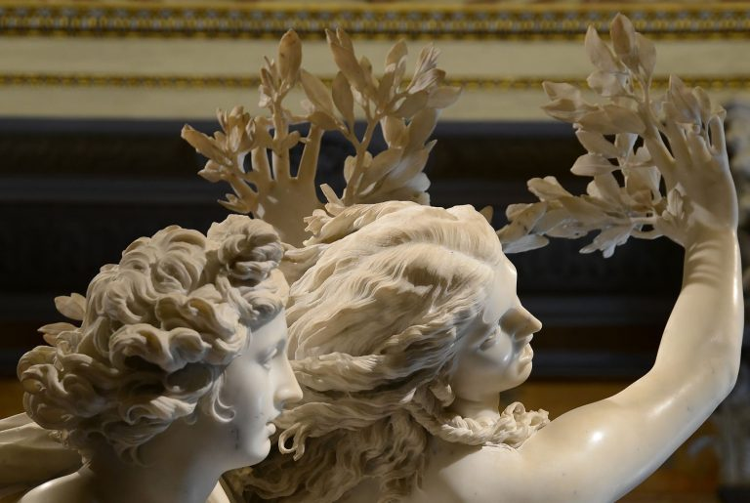
To punish Apollo for insulting the size of his (smaller) arrows, Cupid shot him with a gold-tipped arrown of love and shot the nymph Daphne with a lead-tipped arrown of hatred. When Apoll was about to catch Daphne, her father (the river god Peneus) changed her into a laurel tree. In this Renaissance sculpture, Bernini captures the moment of metamorphosis, with her hands becoming leaves.

‘Cum Laude’ Certificate:
Manuel Cantillo, Hana Conte, Callie Fox, Cameron Kline, Madelyn Smith, John Trokan,
Adelynn Woodward

‘Magna Cum Laude’ Certificate + Ribbon:
Shriyan Masineni, Ari Symonds (top Summit score!)

