2026 Pegasus Mythology Exam
The Pegasus Mythology Exam is a multiple-choice test given every February to over 4,900 middle school students from across the United States. This exam includes the origins of the classical gods, the rule of the Olympians, and a special section on ‘The Underworld.’

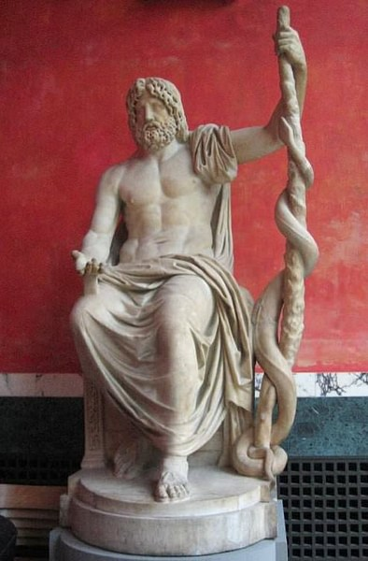
Asclepius, the son of Apollo and the god of healing, is always shown with a staff and one snake.
He angered the gods and lost his life for bringing the dead back to life.

The 6th graders took a 40-question test, and 61% earned an award this year.

‘Cum Laude’ Certificate (30-33):
Will Ahouse, Anna Cafardi, Patrick Goebel, Matti Milam, Cole Rinehart, Sebastian Scharf,
Janie Wendling, Frankie Wirtz

Ribbon + ‘Magna Cum Laude’ Certificate (34-36):
Quinn Harding, Rory Hussey, Nathan Jackson, Blake Owens, Zoa Pratt, Cora Symonds,
Oliver Walker, Jack Wendling

Silver Medal + ‘Maxima Cum Laude’ Certificate (37-38):
Jacob Adams, Temi Ajayi, Kai Devendorf, Carter Marsh, Nina Robinson

Gold Medal + ‘Summa Cum Laude’ Certificate (39):
McKenzie Bell, Luca Pancheri, Amelia Wilson

Gold Medal + ‘Summa Cum Laude’ Certificate + Perfect Score! (40)
Amelie Avila, Eloise Goico, Alicia Palacio-Vega, Liam Wiltshire
The 7th and 8th graders took a 50-question test. It included the 40 questions from the 6th grade exam with 10 more detailed questions on ‘The Underworld.’ 83% of Summit 7th and 8th graders earned an award this year.

‘Cum Laude’ Certificate (40-43):
Maddie Burns, Mia Gehring, Elise Goebel, Ruby Hayes, Lauren Mueller, Madie Richard,
Gwen Suder

Ribbon + ‘Magna Cum Laude’ Certificate (44-46):
Macey Adams, Elliot Fox, Carrigan Sams

Silver Medal + ‘Maxima Cum Laude’ Certificate (47-48):
Tofunmi Ajayi, EJ Clements, Lily Finkleman, Teddy Fulton, Sydney Koo,
Andrea Pérez Sánchez, Rebeca Pérez Sánchez, Matti Hofmann, Liam Roberts,
Noah Roberts, Hailey Wise

Gold Medal + ‘Summa Cum Laude’ Certificate (49):
Evan Gockerman, Evelyn Paulsen, Sophie Pressey, Millie Rich

Gold Medal PERFECT SCORE + ‘Summa Cum Laude’ Certificate (50):
Michaela Bell, Rachel Burkart, James Finkleman, Ava Maly, Hudson Pfeffer,
Emma Rinehart, Russell Roth, Ivy Sousa

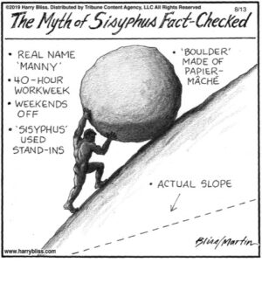
Sisyphus tricked Death and was given an unattainable task in the Underworld:
to try to push a boulder up a steep hill but never accomplish the goal. His eternal torture gives us the English word Sisyphean.

