2026 Exploratory Latin Exam

Over 700 students competed in the 22nd annual Exploratory Latin Exam. Its purpose is to promote enthusiasm for the classical world in elementary and middle schools. The ELE is a 50-question multiple choice exam on derivatives, Roman life, mythology, art & architecture, etc. This year’s exam included 10 ‘special topic’ questions on ‘Daily Life in Ancient Rome.’ 19% of Summit 6th graders earned an award!

Questions included:
- The architect designed a well-fenestrated room. What would you expect to see there? many windows
- A victorious Roman general wore a special toga during a triumphal procession through the city. What was the name of this toga, which was richly colored and decorated? the toga picta
- You play violin in a group with five musicians. Based on the Latin number, what is the name for this group? a quintet

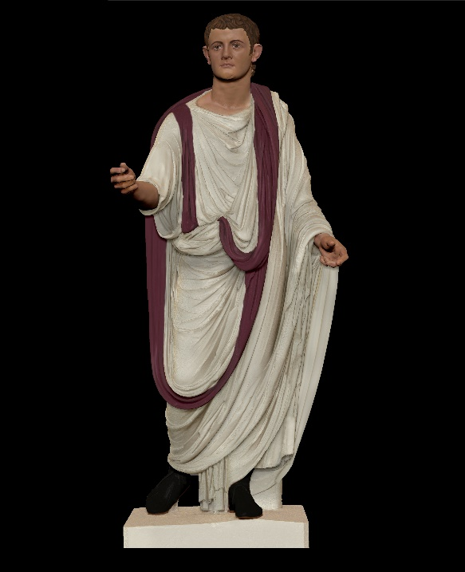
This reconstruction shows a Roman wearing a toga praetexta.
This ‘bordered toga’ was worn by children, senators, and certain priests.

‘Cum Laude’ Certificate + Ribbon (35-39):
Amelie Avila, Nathan Jackson, Amelia Wilson, Liam Wiltshire
‘Magna Cum Laude’ Certificate + Ribbon (40-45):
Eloise Goico, Alicia Palacio-Vega, Luca Pancheri, Nina Robinson
‘Summa Cum Laude’ Certificate + Ribbon (46-49): Temi Ajayi

