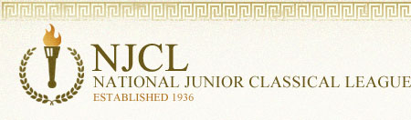

3,034 students took the online Classical Etymology Exam. It was a 50 question, multiple choice exam. Its purpose is to test a student's knowledge of both Latin and Greek derivatives and their usage in the English language. 47% of Summit students earned awards.

Bronze Medal
Tofunmi Ajayi, Chelsea Beyerbach, Emily Bolan, Rachel Burkart, Maddie Burns,
Livia Butcher, Manuel Cantillo, EJ Clements, Lily Fecher, James Finkleman, Teddy Fulton,
Kyan Gatewood, Mia Gehring, Evan Gockerman, Liam Kenney, Sydney Koo,
Landon Miller, Russell Roth, Carrigan Sams, Josh Scott, Ivy Sousa, Gwen Suder,
Hailey Wise, Adelynn Woodward
Silver Medal
Hana Conte, Callie Fox, Will Fox, Evelyn Paulsen, Andrea Pérez Sánchez, Liam Roberts,
Daniel Winhusen
Gold Medal
Lily Finkleman, Rebeca Pérez Sánchez, Hudson Pfeffer, Emma Rinehart,
John Trokan (top Summit score!)

1,218 students took the online Roman Civilization Exam. Its purpose is to test a student’s knowledge of ancient Roman life, government, and culture. It was a 50 question, multiple choice exam. 53% of Summit students earned an award.

Bronze Medal
Tofunmi Ajayi, Chelsea Beyerbach, Manuel Cantillo, EJ Clements, Hana Conte,
Van Devendorf, Tristan Dona, James Finkleman, Evan Fox, Will Fox, Teddy Fulton,
Kyan Gatewood, George Kane, Collin McGuire, Olivia Miele, Liam Roberts,
Rebeca Pérez Sánchez, Josh Scott, Gwen Suder, Hailey Wise, Adelynn Woodward
Silver Medal
Macey Adams, Michaela Bell, Cameron Kline, Matti Hofmann, Ava Maly, Evelyn Paulsen,
Emma Rinehart, Ivy Sousa, John Trokan (top Summit score!)

1,971 students took the online Latin Vocabulary Exam. It was a 70 question, multiple choice exam. 6% of Summit students earned an award.

Bronze Medal
Evelyn Paulsen, Liam Roberts, John Trokan

Silver Medal
Shriyan Masineni, Rebeca Pérez Sánchez

Over 300 students took the online Hellenic Civilization Exam. It was a 50 question, multiple choice exam on all aspects of ancient Greek language, culture, history, and literature. 14% of Summit students earned an award.

Bronze Medal
Macey Adams, Ellie Mosbacher, Rebeca Pérez Sánchez, Griffin Nuss, Josh Scott, Ivy Sousa

Silver Medal
Michaela Bell, Evan Gockerman, Sophie Pressey, Liam Roberts, Hailey Wise

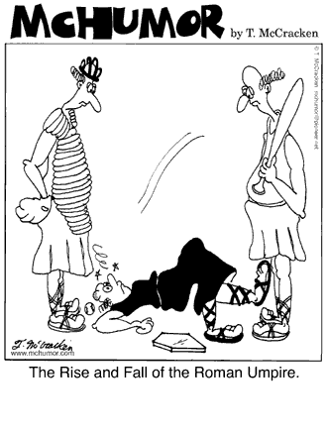
Very punny.

